Lab 1
1. Write a C program to simulate the following CPU scheduling
algorithm to find turnaround time and waiting time n arrival time
a) FCFS

#include <stdio.h>
int main() {
int n, i;
printf("Enter total number of processes: ");
scanf("%d", &n);
int at[n], bt[n], ct[n], tat[n], wt[n];
for(i = 0; i < n; i++) {
printf("Process [%d]\n", i+1);
printf("Arrival time: ");
scanf("%d", &at[i]);
printf("Burst time: ");
scanf("%d", &bt[i]);
}
ct[0] = at[0] + bt[0];
for(i = 1; i < n; i++) {
if(ct[i-1] < at[i])
ct[i] = at[i] + bt[i];
else
ct[i] = ct[i-1] + bt[i];
float total_tat = 0, total_wt = 0;
for(i = 0; i < n; i++) {
tat[i] = ct[i] - at[i];
wt[i] = tat[i] - bt[i];
total_tat += tat[i];
total_wt += wt[i];
}
printf("\nProcess\tArrival Time\tBurst Time\tCompletion Time\tTurnaround Time\tWaiting Time\n");
for(i = 0; i < n; i++) {
printf("%d\t%d\t\t%d\t\t%d\t\t%d\t\t%d\n",
i+1, at[i], bt[i], ct[i], tat[i], wt[i]);
}
printf("\nAverage Turnaround Time: %.2f", total_tat/n);
printf("\nAverage Waiting Time: %.2f\n", total_wt/n);
printf("Nidhi R Khabiya 1wa24cs186\n");
return 0;
}

Output
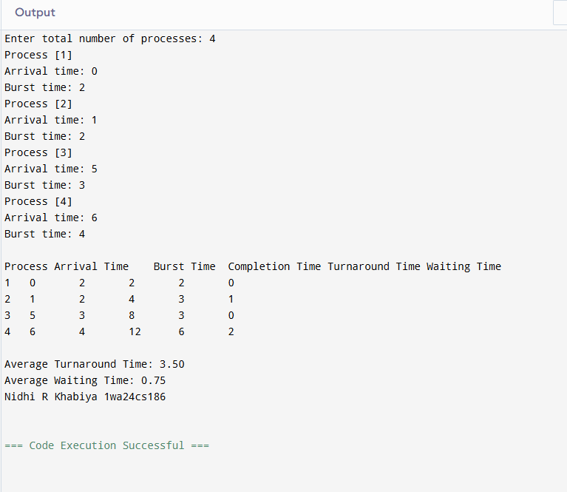
b) SJF non preemptive

#include <stdio.h>
int main() {
int n, i, j, pos;
printf("Enter number of processes: ");
scanf("%d", &n);
int at[n], bt[n], ct[n], tat[n], wt[n], pid[n];
float total_tat = 0, total_wt = 0;
printf("Enter arrival times:\n");
for(i = 0; i < n; i++) {
scanf("%d", &at[i]);
pid[i] = i + 1;
}
printf("Enter burst times:\n");
for(i = 0; i < n; i++) {
scanf("%d", &bt[i]);
}
for(i = 0; i < n - 1; i++) {
pos = i;
for(j = i + 1; j < n; j++) {
if(bt[j] < bt[pos])
pos = j;
}
int temp;
temp = bt[i]; bt[i] = bt[pos]; bt[pos] = temp;
temp = at[i]; at[i] = at[pos]; at[pos] = temp;
temp = pid[i]; pid[i] = pid[pos]; pid[pos] = temp;
}
ct[0] = bt[0];
for(i = 1; i < n; i++) {
ct[i] = ct[i-1] + bt[i];
}
for(i = 0; i < n; i++) {
tat[i] = ct[i] - at[i];
wt[i] = tat[i] - bt[i];
total_tat += tat[i];
total_wt += wt[i];
}
printf("\nSJF Scheduling:\n");
printf("PID\tAT\tBT\tCT\tTAT\tWT\n");
for(i = 0; i < n; i++) {
printf("P%d\t%d\t%d\t%d\t%d\t%d\n",
pid[i], at[i], bt[i], ct[i], tat[i], wt[i]);
printf("\nAverage turnaround time: %fms", total_tat/n);
printf("\nAverage waiting time: %fms\n", total_wt/n);
printf("Nidhi R Khabiya 1wa24cs186\n");
return 0;
}

Output
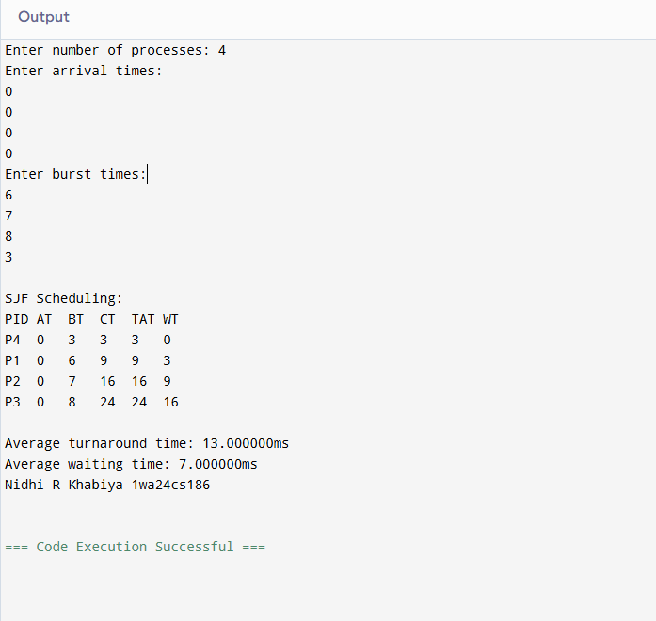
c) SJF preemptive

#include <stdio.h>
int main() {
int n, i, completed = 0, time = 0, min_bt, shortest;
printf("Enter the number of processes: ");
scanf("%d", &n);
int at[n], bt[n], ct[n], tat[n], wt[n], visited[n];
for(i = 0; i < n; i++)
visited[i] = 0;
for(i = 0; i < n; i++) {
printf("Enter arrival time and burst time for process %d: ", i+1);
scanf("%d %d", &at[i], &bt[i]);
}
while(completed < n) {
min_bt = 9999;
shortest = -1;

for(i = 0; i < n; i++) {
if(at[i] <= time && visited[i] == 0 && bt[i] < min_bt) {
min_bt = bt[i];
shortest = i;
}
}
if(shortest == -1) {
time++;
} else {
time += bt[shortest];
ct[shortest] = time;
visited[shortest] = 1;
completed++;
}
}
float total_wt = 0, total_tat = 0;
for(i = 0; i < n; i++) {
tat[i] = ct[i] - at[i];
wt[i] = tat[i] - bt[i];
total_wt += wt[i];
total_tat += tat[i];
}
printf("\nPID\tAT\tBT\tCT\tTAT\tWT\n");
for(i = 0; i < n; i++) {
printf("%d\t%d\t%d\t%d\t%d\t%d\n",
i+1, at[i], bt[i], ct[i], tat[i], wt[i]);
}
printf("\nAverage Waiting Time: %.2f\n", total_wt/n);
printf("Average Turnaround Time: %.2f\n", total_tat/n);
printf("Nidhi R Khabiya 1wa24cs186\n");
return 0;
}

Output
